Dance w/ Ms. Moss
Intro to Dance: Ballet/Modern/African/Jazz
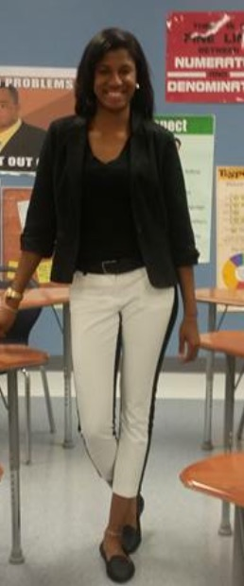

Upcoming Events

February 28
Black History Month Program

March 10
Charlotte Ballet Presents: “Sleeping Beauty”
April 2017
Master Class: Guest Dancer

May 1
Spring Arts Program

All about Ms. Moss!
I am super excited to be teaching this new course at Charlotte Secondary this semester. I am a graduate of Johnson C. Smith University with a B.A. in Mathematics. I am originally from Brooklyn, NY where I spent most of my childhood. Outside of CSS, I am the coach of Independence High School Marching Band Gold-N-Motion Dance Team. I have been dancing since I was in Elementary school and cannot wait to share my love for dance with you all!

Periscope: @Thebossy
Email: Quadasia.walker-moss@charlottesecondary.org
Dancers/Parents:
“Dance is a conversation between body and soul”
This course introduces students to dance by engaging with the multiple purposes of the art form through hands-on experiences, by exploring the history and current state of dance as a form of creative expression and social, religious, and cultural practice, and by investigating dance as it relates to other artistic disciplines.
During the session we will explore elements of a wide variety of dance styles and practices through movement explorations, dance-making, readings, discussions, videos, written responses, collaborative projects, and attendance at live dance events. By examining dance in both global and local contexts we will move towards a fuller appreciation and understanding of the influence of dance in our everyday lives as well as an embodied reflection and expression of the world in which we live.
This course will be split into three distinct units. The first will explore how dance is relevant to your life. You will be asked to participate in and reflect upon a movement class and to complete a project that draws from your own personal dance heritage. We will also begin to build a movement vocabulary within the class that we will draw on later in the semester. The second unit will focus on refining your skills of observation and description when viewing dance and making and revising an original piece of dance through collaboration. We will discuss elements of theatrical production and site-specific choreography as well as how to write an articulate dance analyses paper. The third unit will culminate in a final collaborative project that incorporates knowledge and new understanding gained over the semester.

Course Objectives:

Participate in movement and other live dance events to gain a greater appreciation for and understanding of the physical, creative and performative processes involved in the art form.

Dressing Out
All students are required to change out of their school clothes and into proper dance attire before entering dance class. You have 6 minutes after the bell rings or you will be marked TARDY. This includes:
• Solid black shirt or leotard
• Solid black bottoms (ex: leggings)
• Solid black socks or dance shoes (if you would like to order dance shoes through me please let me know)
• Hair is pulled back, and is neatly tucked away
Dos and Don’ts
Students are NOT allowed to have the following:
• Labels or pictures on shirts or bottoms
• Street shoes
• Headbands, hats, scarves, hair wraps, etc
• Shorts • Necklaces, bracelets, watches, and/or rings ¬ Stud earrings are allowed if smaller than a pencil eraser.

Describe the functions of dance and the relationship between dance and the greater artistic, social, cultural and political landscape in which it was created and currently exists.

Articulate a definition of dance and the role, form, intention, and interpretation plays in delineating dance movement from non-dance movement.

Analyze live and recorded dance performances through clear and articulate written and oral responses that describe the work and personal reflections to it.

Work collaboratively with other students to research, integrate and present material in a creative and effective manner.

Give and receive feedback in order to revise a piece of original choreography.

Consider the potential of dance as empowering educational tool and vehicle for personal and communal development.

Seek and form connections between concepts covered in this class and other fields of study and interest.

More Important News
Eoc- 25%
Homework- 15%
Classwork/Projects- 30%
Assessments- 25%
Grading Scale:
A 90-100 B 80-89
C 70-79 D 60-69
F 59-below
**Students are not exempt from work when they are absent. You must get your work completed upon return to school.

